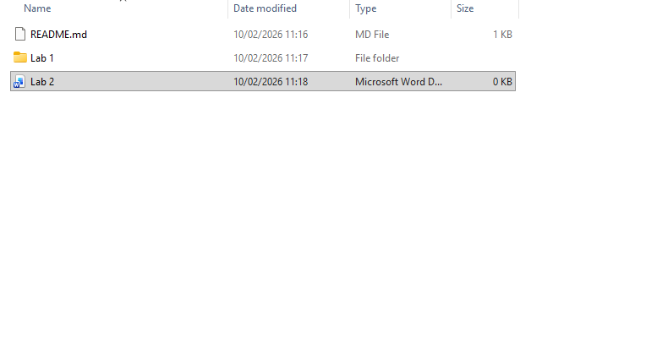
I added everything from last week into the new assignment as well as pulled the new repository from github classrooms
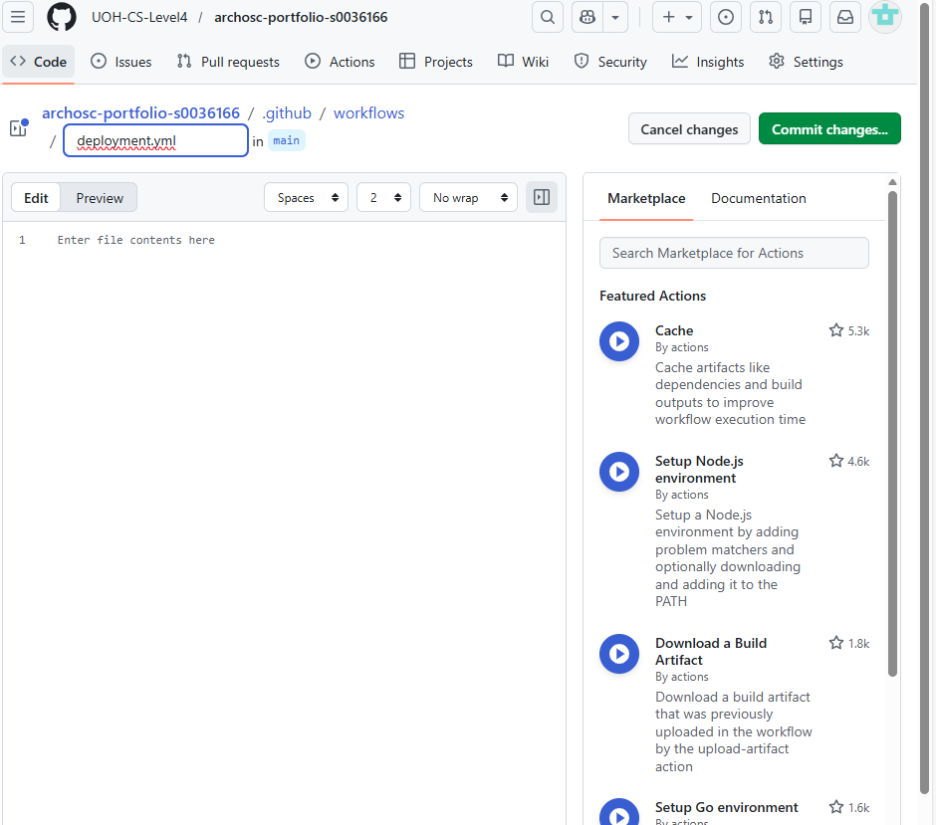
I created a new CI/CD pipeline
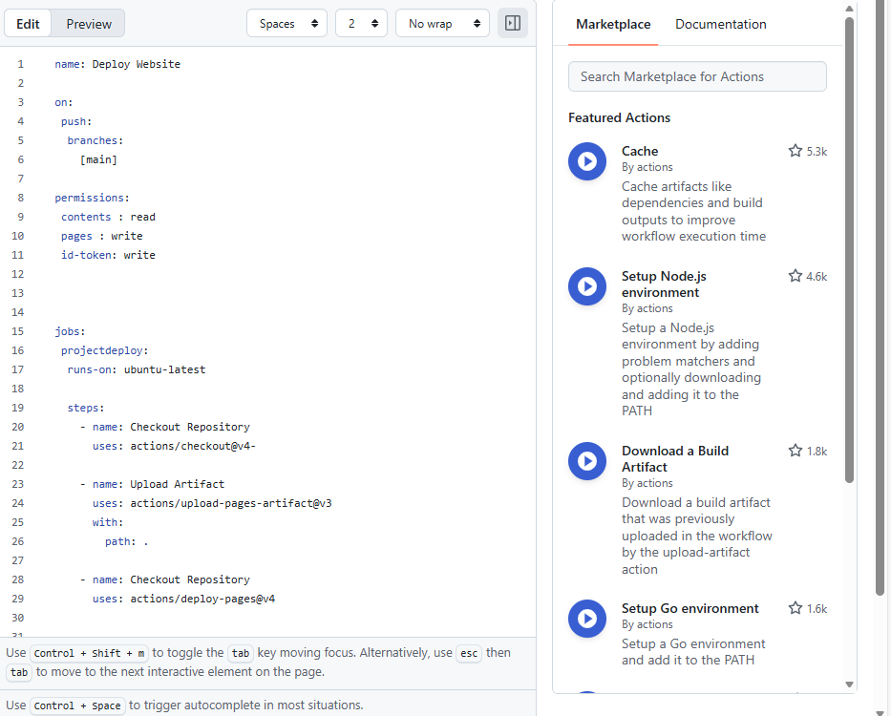
I added a VM that allows us to push to GitHub pages a well as a GitHub artifact and finished my YAML
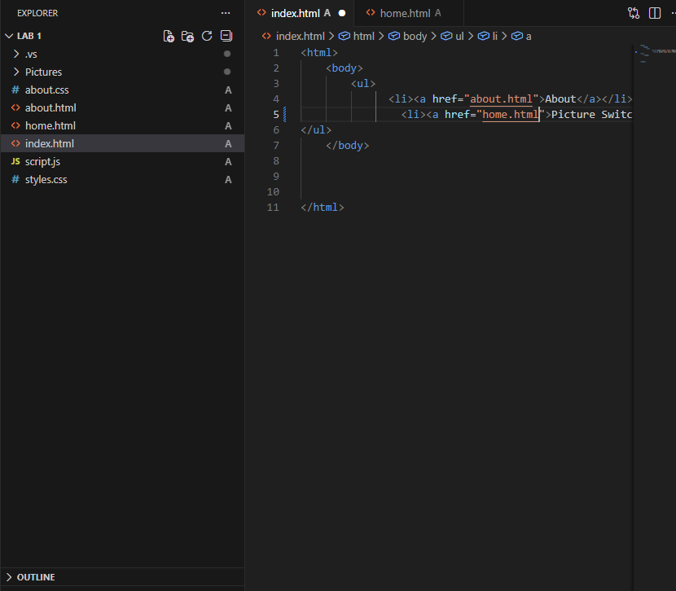
I added a homepage which includes hyperbars as the index

